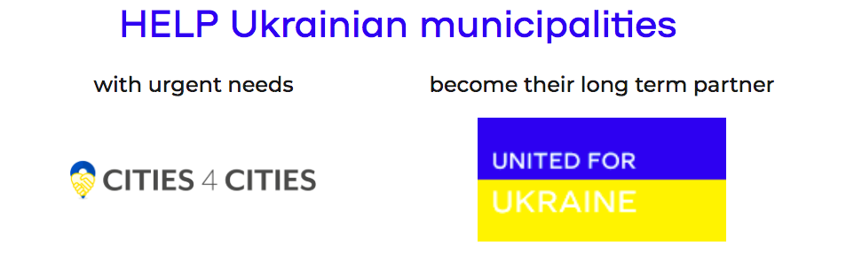

Invitation
Networking Session with Ukrainian Local Communities
at World for Ukraine Summit (Rzeszów-Jasionka, 7-9 December 2022)

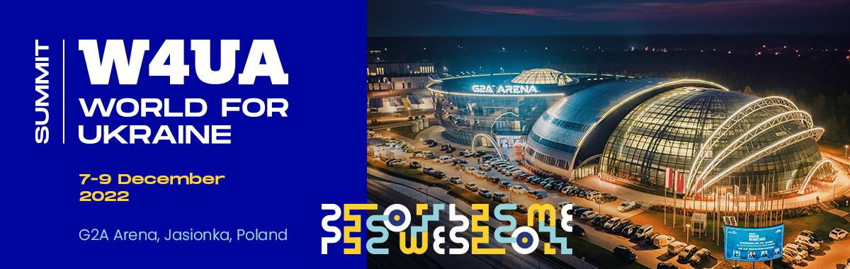

Introduction

From the first days of the Russian full-scale invasion, Ukrainian heads of communities have been on the front lines - organizing the delivery of humanitarian goods, carrying out the evacuation of civilians, organizing territorial defense and trying to maintain the operation of critical and social infrastructure despite constant shelling.

A few years ago, Ukraine underwent a decentralization reform and communities received more powers. They got stronger, became more self-sufficient, and today they are passing a difficult endurance test with dignity. At the same time, they are already thinking about the future, adjusting development plans, developing reconstruction projects and discussing further steps in decentralization reform. This meeting at the World for Ukraine (W4UA) Summit is an opportunity to learn about these processes from the representatives of local communities of Ukraine and to develop deeper ties and partnerships with municipalities abroad.

The meeting gathers:

- 33 mayors from all around Ukraine, representing different small- and middle-sized local governance associations, different regions of Ukraine - both frontline, de-occupied and rear, will participate in the event and present their communities, share their thoughts on the role of local governance in recovery of Ukraine after war. This includes mayors of Skadovsk, Lviv, Pokrovska, Dunayevetska, Ivankivska, among others.

Who is invited to participate:

- Mayor’s and local governance leaders from EU, who express wish to find partners in Ukraine;

- Representatives of international organizations and projects working with local governance in Ukraine and who promote municipal partnerships as an instrument of Ukraine’s recovery.

Format of the meetings

These meetings will take place within the broader framework of the World for Ukraine Summit program: www.w4ua.com.

7 December - 16.00-18.00
Ukrainian self-governance in the war. Struggle, challenges, future.
Presentation & networking session dedicated to the Day of Local Governance in Ukraine

Moderator: Krzysztof Stanowski, Director, International Cooperation Centre, City of Lublin
Speakers: 6 local governance leaders from Ukraine - tbc.

Videos: 2 min. video stories from 6 Ukrainian communities at war will be showcased.

Discussion:
What is the role of local governance in Ukraine's war for independence 2022? How can municipal partnerships with European communities assist in Recovery of Ukraine? How international humanitarian missions and organizations can support Ukrainian communities in times of challenges.

Networking in groups:
After the presentation, participants interested in establishing contacts with the Ukrainian community leaders will be divided into smaller discussion groupswhere they will have a chance to discuss specific lessons learned, stories, and forms of cooperation in a collaborative setting.

(See below information about other related sessions)
9 December - 13.30-15.00
The Role of Municipal Partnerships in The Recovery of Ukraine
Panel discussion moderated by Serhiy Loboyko, Head of Center for Innovation Development and Co-coordinator of Kyiv Participatory Budget. Speakers include Mayor Konrad Fijołek, City of Rzeszów (W4UA Summit host city), SALAR (United for Ukraine), Congress of Local and Regional Authorities of CoE (Cities 4 Cities), CEMR and others.

9 December - 15.00-16.30
War Zone Specific Challenges - Heating, Water Supplies, and Delivery of Aid
Panel discussion with the Mayors of Skadovsk and Pokrovska.

9 December - 9.30-11.00
Rebuilding Ukraine's Urban Spaces and Infrastructure
Panel discussion with the Mayor Voznesenska, Ms Marina Denysiuk of the National Council of Recovery of Ukraine, and Mr Dmytro Klets from the Reform Support Team of Ministry of Infrastructure of Ukraine.

9 December - 9.30-11.00
Rehabilitation of Visible and Invisible War Scars
Panel discussion with the representatives of UNBROKEN, Mr Andriy Sadovyi Mayor of Lviv, International Medical Corps, and Revived Soldiers Ukraine.

9 December - 11.00-12.30
Ukrainian Children's Education at Home, Abroad, and Online
Panel discussion moderated by Krzysztof Stanowski (City of Lublin) with Mr Oleh Fasolya, head of the component of education support at the local and regional levels of the Swedish-Ukrainian project "Supporting Decentralization in Ukraine".

For full program of the event see: www.w4ua.com.

