DEVELOPMENT STRATEGY OF THE TOWN OF ENERGODAR
For the period of time till the year 2015

Vision of the future town:

ENERGODAR is a town with a high level of cultural development of the population, an advanced economic structure; it is a pollution-free, politically correct town.

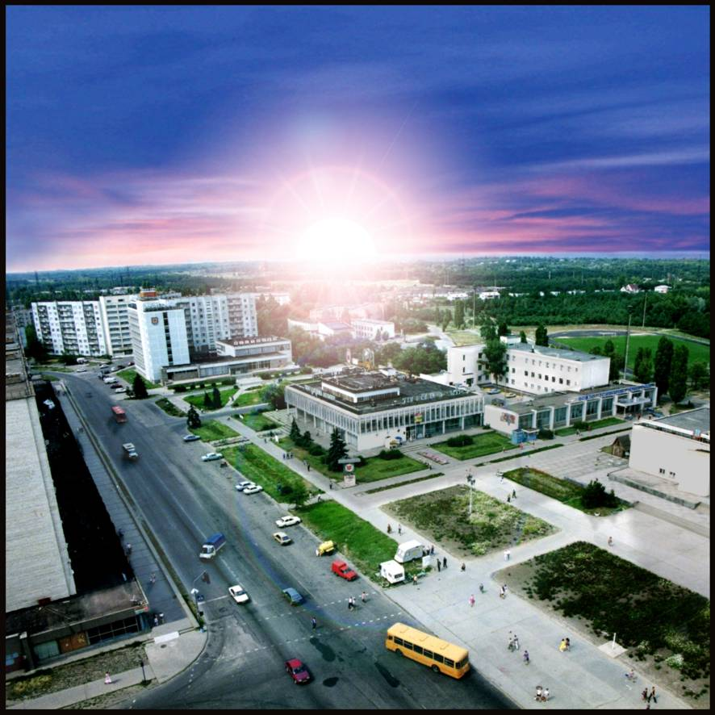  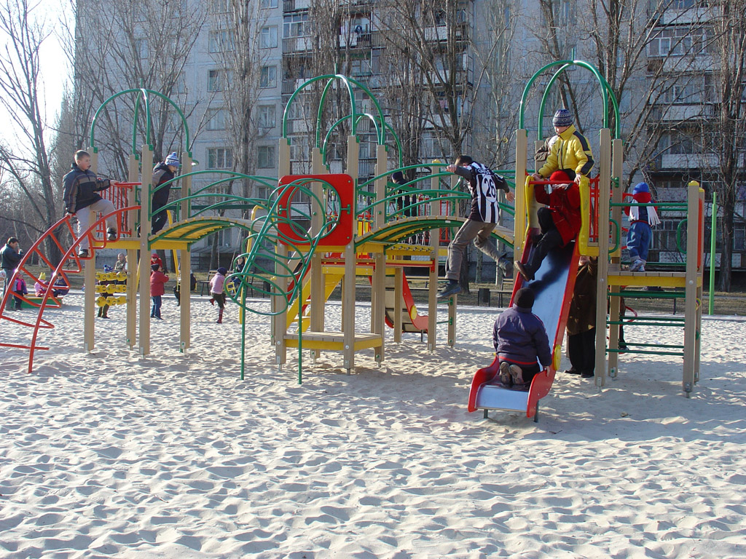  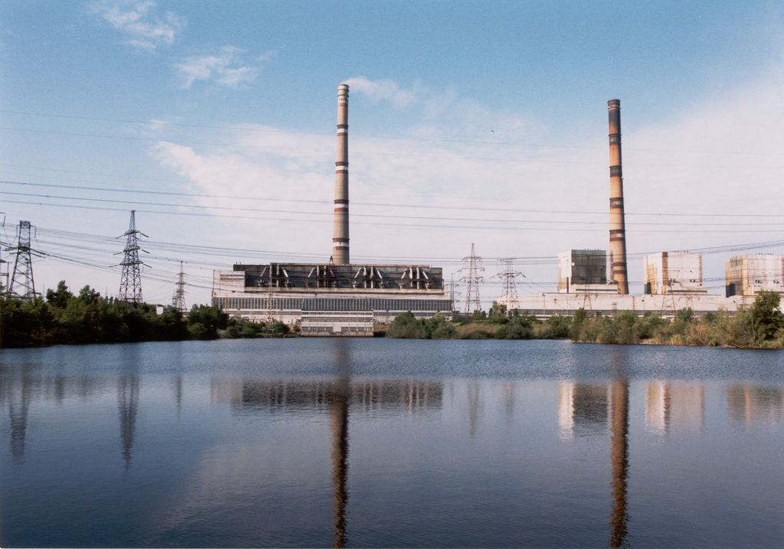  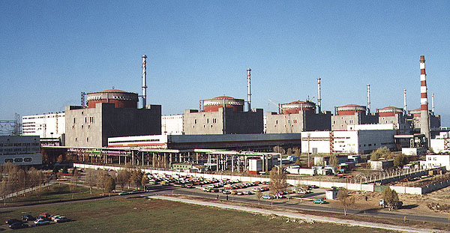 | * a town with the community, united on the principles of spirituality and patriotism;  * a town with the developed civil society, based on the legitimacy, nomocracy and on the equal partnership of citizens and governance, with the public authority of high professional skills and moral qualities; a town with the perfect and self-sufficient self-administration;  * a town with the high standard of life and with the legal safeguard of its citizens;   * a town with the developed and multifunctional economical structure;  * a town with the developed system of business support;  * a town with the ecological educated population and with the environmentally friendly industry.

